**C2 – S2 – PRACTICE CSS CASCADING**

Please write what you did here : <https://docs.google.com/spreadsheets/d/19CMFaTkZ-y1OiOLU4iIjvY0REUBtJuZyKPrjDO79Xpw/edit?usp=sharing>

You have 4 steps and at each step, you update you HTML and CSS files.

**1st step**

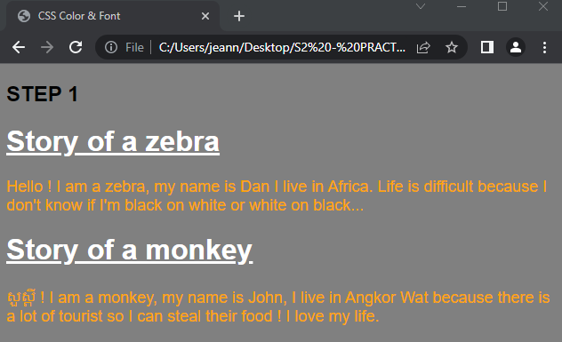

**- HTML Tags use in body:**

1. h1

2. p

3. h2

**- CSS Properties use:**

1. background: gray;

2. font-family: Arial, Helvetica, sans-serif;

3. color: white;

4. text-decoration: underline;

5. font-size: large;

6. color: orange;

**2nd step**

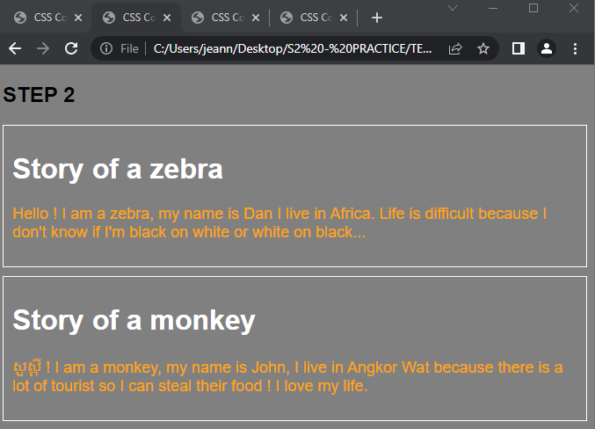

**- HTML tags use in body:**

1. div

2. h1

3. h2

4. p

**- CSS Properties use:**

1. background: gray;

2. font-family: Arial, Helvetica, sans-serif;

3. border: 1px solid white;

4. margin-top: 10px;

5. padding: 10px;

5. color: white;

6. font-size: large;

**3rd step**

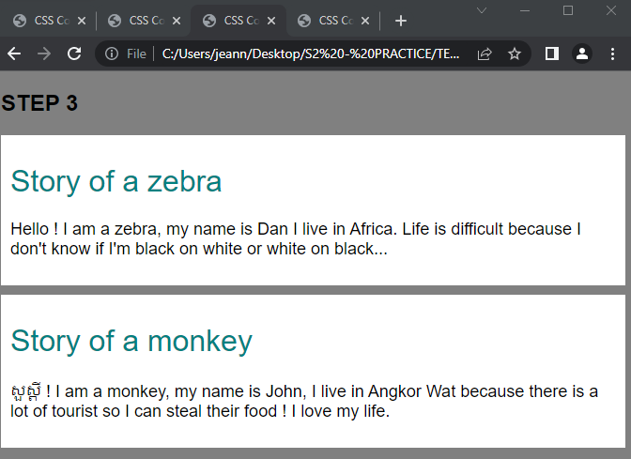

**- HTML tags use in body:**

1. div

2. h1

3. h2

4. p

**- CSS Properties use:**

1. background: gray;

2. font-family: Arial, Helvetica, sans-serif;

3. background: white;

4. margin-top: 10px;

5. padding: 10px;

6. color: teal;

7. font-size: large;

8. font-weight: 300;

**4th step**

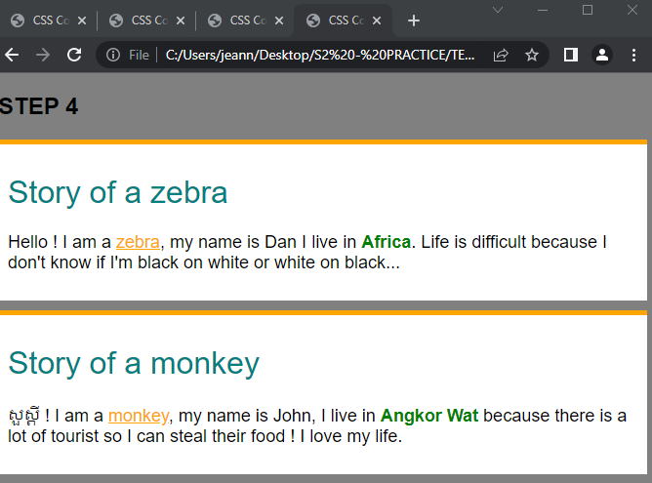

**- HTML tags use in body:**

1. div

2. h1

3. p

4. strong

5. u

6. h2

**- CSS Properties use:**

background: gray;

font-family: Arial, Helvetica, sans-serif;

border-top: 5px solid orange;

margin-top: 10px;

padding: 10px;

background: white;

color: teal;

font-weight: 300;

font-size: large;

color: orange;

color: green;